Christopher Valerio

**COMMAND LINE FLAGS: PLEASE SEE BELOW FOR EXAMPLE**

java SearchEngine -CorpusDir C:\Users\Christopher\eclipse-workspace\CS335_Projects\Prj1\Corpus -InvertedIndex indexFileOutput.txt -StopList stoplist.txt -Queries QueryFile.txt -Results ResultsFile.txt -Snippet 3 -Stem true -Output both

**The Program at a a minimum requires the following flags to run**

-CorpusDir

* directory path to your document corpus

-InvertedIndex

* file name to which the contents of the Inverted Index will be outputted to

-StopList

* name of stop list file which contains a series of words that will be omitted from inverted index

-Queries

* Name of Query file containing the queries that will be ran against the search engine

-Results

* name of the results file, to where program will output the results of our queries against inverted index

**These Flags are not required to execute the program**

-Snippet

* an integer value used when determining document snippets for each for each Word/Term in the QueryFile. an integer value must follow the '-Snippet' flag. Program will not allow you to calculate snippets without specifying the flag. Value of “true” or “false” is used when specifying snippet flag

-Stem

* Stem flag is used to specify whether or not user wants to apply Porters Stemming Algorithm to the search engines querying process. The '-Stem' flag can be omitted and Porters Stemming Algorithm will only be applied if the value to the '-Stem' flag is the string "true" spelt identically

-Output

* Whether the results are read and/or displayed on a GUI or using a text file should be another option flag from command line. This "output" switch accepts 3 values: “gui”, “txt”, or “both”.

**MAIN MENU: Presented with a drop down menu of options. You can either Query on a specified file, Calculate Snippets on a specified file, Query/Search for specific Word,Query/Search for specific Document, and Terminate Program**

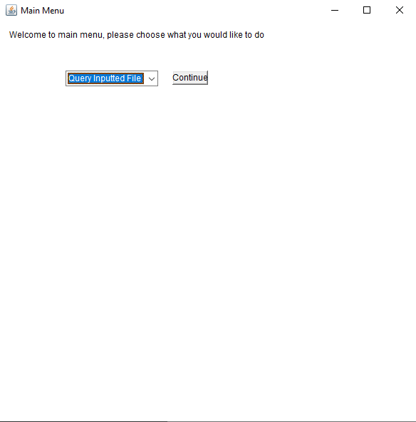

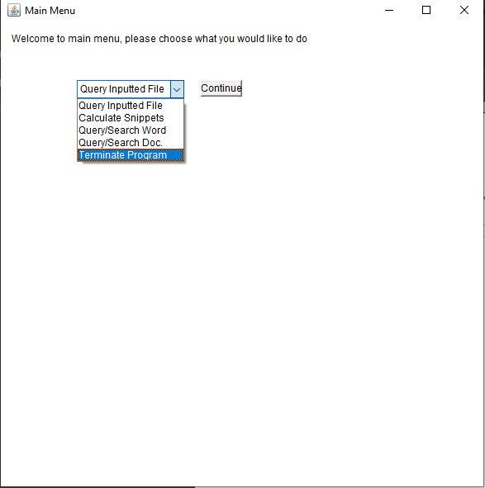

**QUERY INPUTTED FILE: IF 1st OPTION FROM DROP DOWN IS SELECTED**

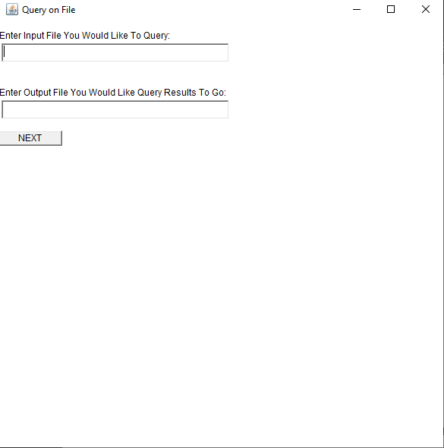

* To Query on inputted file
  + User is asked to specify name of input file they would like to query
  + User is asked to specify name of output file they would like the query results outputted too
  + To continue an input file must be specified and if no output file is specified by default the file specified after -Results flag will be used
  + Hit next button to continue to query after files have been specified, or hit ‘X’ button in top right to go back to main menu
* Query files need to be of same format as “QueryFile.txt”, which can be found along with the submission of this project

**Calculate Snippets: IF 2nd OPTION IS SELECTED FROM DROP DOWN MENU**

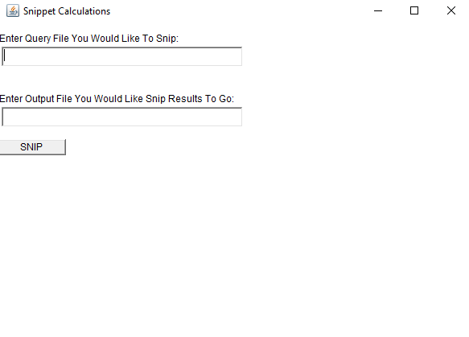

* To Calculate Snippets
  + If not input or output file is specified, QueryFile specified at command line will be used as input, and a file called "QuerySnippetResults.txt" will be used to hold the generated snippet output
  + Otherwise users own specified queryFile, and output file is used

**Query/Search for individual Word/Term: IF 3rd OPTION IS SELECTED**

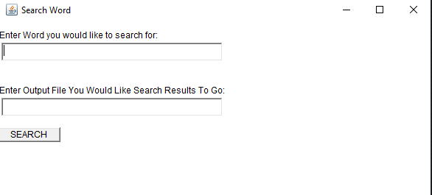

* To Search for Word
  + You must specify the word you wish to search for. If no output file is specified, a default output file called “searchWordResults.txt” is used
  + Hit search button to search for word after data has been entered or hit ‘X’ button in top right corner to exit to main menu

**Query/Search for individual Document: IF 4th OPTION IS SELECTED**

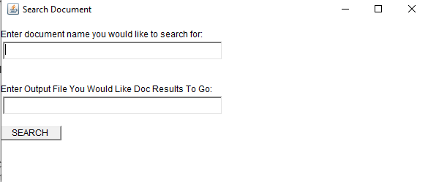

* To Search for Document
* You must specify the document you wish to search for. If no output file is specified, a default output file called “searchDocResults.txt” is used
* Hit search button to search for document after data has been entered or hit ‘X’ button in top right corner to exit to main menu

**TO QUIT PROGRAM:**

**Select “Terminate Program” from main menu or use ‘X’ button in top right corner of main menu**

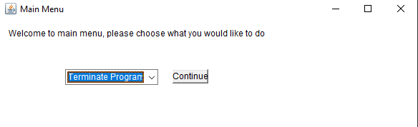

**IF -OUTPUT FLAG IS SET TO EITHER “gui” or “both” output will be displayed in the GUI. Otherwise output will just be shown in the specified file.**